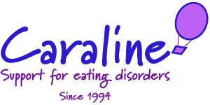
Client Referral Form
Full Name: | Date of Birth:
Home Address: | Email Address:  Consent given to contact by:  Post and/or email: Post yes/no Email Yes/No
Contact telephone numbers (please mark preferred number to contact with a ‘P’).  Mobile:  Home:  Consent given to contact by telephone: yes/no  Consent given to leave voicemail: yes/no | Current Weight:  Height:  Ethnicity:  Do you have type 1 diabetes? Yes/No  Do you have any mobility issues? Yes/No  (it is necessary to climb a few steps to access building)
GP details  GP’s name:  Surgury Name:  Address:  Telephone Number:  NHS No (if known):  Consent to contact GP Yes/No  (If no, please note we will be unable to proceed any further with this referral). | Presenting Problem  (Please provide as much information as possible below regarding current eating behaviours, i.e. restricting, self-induced vomiting, binge eating. Purging, and any significant weight change within the last 3 months, together with details of any other mental health issues and any other services supporting you, i.e. Mental Health Team or Eating Disorder Service).
How did you hear about Caraline?  Have you ever been referred to the Community ED Service in Dunstable? If so please provide a date: | Date of referral:  Method of referral: email/letter/telephone/fax
To be completed by office staff -
Date added to database: | Date added to portal:

