Important Service Demand Update

We must advise that as a result of the continuous unprecedented demand on our service, unfortunately it is necessary for us to temporarily close to any new referrals, to enable us to manage the risk of service users wishing to access our service.

We therefore confirm we are unable to accept your referral at this time.

We never underestimate the importance of taking this step and believe it is necessary that we are honest about our current demand on service since the COVID -19 pandemic.

Our Clinical Team will continue to review our current situation fortnightly. For updates, please check our website www.caraline.com and our social media pages. You can also contact us on 01582 457474 or email us at admin@caraline.com.

Please see below information we have put together directing potential service users to self-help and other services.

Please be aware that we are not an emergency service. If you are experiencing a mental health crisis the following options are available to you:

   | 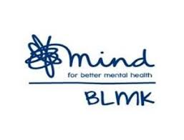 | 
  111 Option 2 | 01582 722225 |   116 123
Open to people of all ages 24/7  A trained mental health professional will be able to offer assessment and support  Also access Crisis Resolution and Home Treatment (CRHT) teams | Open to adults (18+) Tuesday-Friday 5pm-11pm  Phone support delivered by a trained mental health professional from Mind Crisis Cafes | Open to people of all ages 24/7  Contact and talk to a Samaritans listening volunteer
If you are experiencing a physical/medical health crisis, the following options are available to you.
 | 
Open to people of all ages 24/7  A trained call assessor will be able to offer assessment and support and signpost you to the most appropriate care for your condition | Contact your GP within business hours
Please ensure you have regular contact with your GP as your physical and mental wellbeing will remain with your GP.

Support whilst you are waiting:
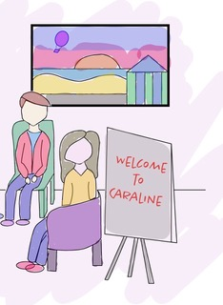 | 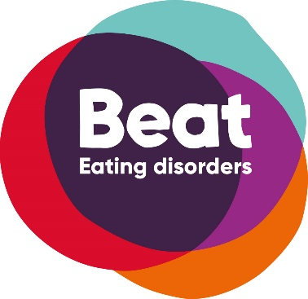
Caraline team members will be available for service updates – please call:  Helpline 01582 457474 between the hours of 9am and 5pm Monday to Friday | Beat Eating Disorders is a National Charity that has various online support and help-lines  beateatingdisorders.co.uk

Caraline encourage you to explore the following self-help resources to help you manage any distress you may be feeling:

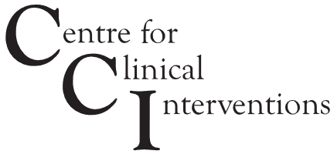 | 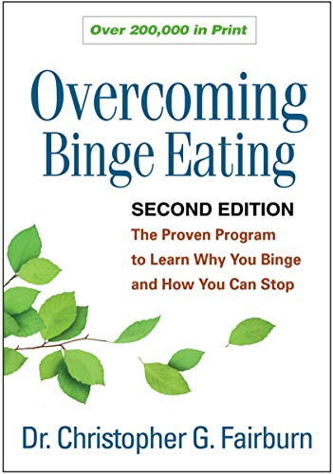
Literature with handouts and workbooks via CCI GOV Eating Disorder Self-Help Resources  Click Here | Sponsored Link | Free online courses and workshops which are easy to access via Zoom  Click Here for Prospectus

We thank you for your patience at this very difficult time.

With best wishes
Team Caraline
On Behalf of Team Caraline
admin@caraline.com | www.caraline.com | 01582 457474
Kline House, 13 George Street West, Luton, Beds LU1 2BJ

Copyright © Caraline 2018 All rights reserved. Our mailing address is: admin@caraline.com
Your receiving this message because you are a registered Caraline user. Do you want to change how you receive these emails? You can update your preferences or unsubscribe by pressing the link and completing the email.

This email and any attachments to it may be confidential and are intended solely for the use of the individual to whom it is addressed. Any views or opinions expressed are solely those of the author and do not necessarily represent those of Caraline.
If you are not the intended recipient of this email, you must neither take any action based upon its contents, nor copy or show it to anyone. Please contact the sender if you believe you have received this email in error.
